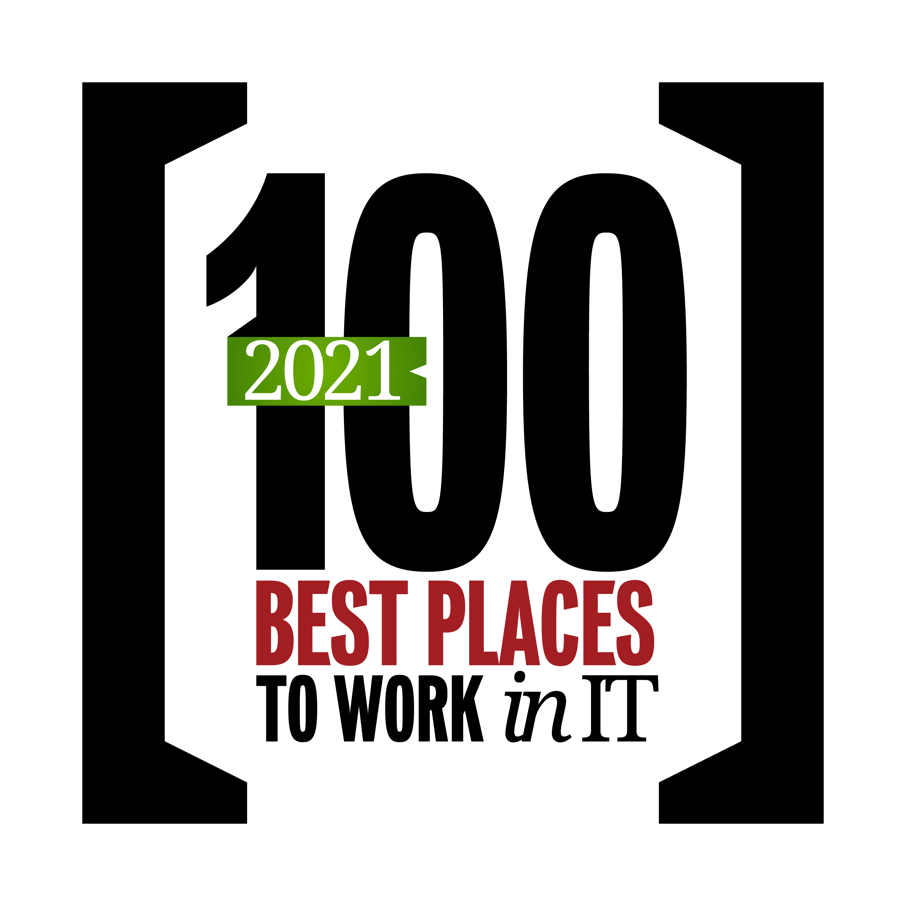

IDG Insider Pro and Computerworld Best Places to Work in IT 2021 Survey
IDG Insider Pro and Computerworld are conducting the 28th annual survey to identify the best places to work for IT professionals. The results of our survey will be released in the Summer of 2021 as a special report that will appear online and in a digital magazine.
Your organization has been nominated for IDG Insider Pro and Computerworld’s Best Places to Work in IT list for 2021, and your responses to this survey are a major factor in the overall selection of organizations and the rankings they receive.

This survey takes approximately 10 minutes to complete. Your individual answers to this survey are confidential, and the results will be used in aggregate form only, combined with those of other survey respondents. Research Results Inc., a third-party research firm, will receive your responses via a secure server that prevents network transactions from being decoded, thus preserving the privacy of sensitive information.

If you have any questions regarding the employee portion of this study or this research project overall, please visit our website to read a detailed FAQ list:
https://www.idginsiderpro.com/article/3448582/about-the-best-places-to-work-in-it.html#faq
- On a scale of 1 to 10, with 10 being extremely important and 1 being not at all important, please rate the importance of each of the following to you in relation to your current job.

Having the means and opportunity to further my career.
Having access to training and opportunities that further my skills.
Being fairly compensated for the work I do.
Being able to work with cutting-edge technologies.
Working with a group of people who are culturally diverse.
Working with a group of people who are ethnically diverse.
Working in a challenging environment.
Working in an enjoyable environment.
Working for an organization that is socially responsible and/or environmentally sustainable.

- How would you rate the employee morale in your IT department?
Excellent
Very good
Good
Fair
Poor

- How stressful do you find your job/workplace?

Very stressful
Stressful
Somewhat stressful
Not very stressful
Not at all stressful

- How satisfied are you with your…?

[Scale: Very satisfied, Satisfied, Neither satisfied nor dissatisfied, Dissatisfied, Very dissatisfied]

Base salary
Work/life balance
Training/career development programs for IT professionals offered by my organization

- How satisfied are you with the following benefits at your organization? If you don’t use a specific benefit that is offered, please check “Don’t use.” If a specific benefit isn’t offered by your organization, please check “Not offered.”

[Scale: Very satisfied, Satisfied, Neither satisfied nor dissatisfied, Dissatisfied, Very dissatisfied, Don’t use, Not offered]

Bonuses
Profit sharing/Employee stock ownership program/401(k)/403b plan
Overtime pay/Comp time for overtime hours worked
Childcare
Elder care and/or services
Flexible hours
Corporate/employee wellness program including onsite fitness center or fitness membership reimbursement, smoking-cessation programs, health screenings, wellness education, etc.
Reimbursement for college tuition or technology certifications
Continuing education/executive education programs
Employee Assistance Program (EAP)
Paid or unpaid sabbaticals
Maternity/paternity leave
Job sharing
Health insurance
Domestic partner/spousal equivalent/same-sex partner benefits
Paid time off (including vacation time, sick time, personal days)
Telecommuting options
Company-sponsored affinity groups (e.g., women in IT, people of color, veterans, etc.)

- On a scale of 1 to 10, with 10 being extremely important and 1 being not at all important, please rate the importance of each of the following benefits to you, regardless of whether the specific benefit is offered by your organization or not.

Health insurance
Paid time off (including vacation time, sick time, personal days)
Bonuses
Profit sharing/Employee stock ownership program/401(k)/403b plan
Overtime pay/Comp time for overtime hours worked
Childcare
Elder care and/or services
Flexible hours
Corporate/employee wellness program including onsite fitness center or fitness membership reimbursement, smoking-cessation programs, health screenings, wellness education, etc.
Reimbursement for college tuition or technology certifications
Continuing education/executive education programs
Employee Assistance Program (EAP)
Paid or unpaid sabbaticals
Maternity/paternity leave
Job sharing
Domestic partner/spousal equivalent/same-sex partner benefits
Telecommuting options
Company-sponsored affinity groups (e.g., women in IT, people of color, veterans, etc.)

- How effective is your organization at:
[Scale: Very effective, Effective, Somewhat effective, Not very effective, Not at all effective]
Communicating benefit information to employees
Communicating career opportunity information to employees

- Please indicate your level of agreement with each statement below.

[Scale: Strongly agree, Agree, Neither agree nor disagree, Disagree, Strongly disagree]

There are opportunities for career growth at my organization.
I have a well-defined career path.
I have access to the tools and technologies I need to do my job.
I have access to new technologies.
I have the opportunity to get involved with interesting projects.
I have a good relationship with my co-workers.
I am proud to work for my organization.
I feel my job is secure.
I have a good relationship with my supervisor.
My organization motivates me to do my best.
I have access to training and education to enhance my skills.
My performance is evaluated fairly and with adequate frequency.
My organization’s corporate culture is positive.
IT management effectively leads the department.
My workload and deadlines are reasonable.
My organization/department has a clearly defined mission.
My job is interesting and challenging.
This is a team-oriented organization/department.
My organization is run ethically and honestly.
My organization recognizes achievements and good work.
My organization treats people fairly and equally, regardless of their job title/function
My organization treats people fairly and equally, regardless of their sexual orientation
My organization treats people fairly and equally, regardless of their religion
My organization treats people fairly and equally, regardless of their race
My organization treats people fairly and equally, regardless of their gender
My organization treats people fairly and equally, regardless of their age
My supervisor is involved and interested in my career development.
IT management involves IT staffers in decisions that affect their jobs.
My organization is a great place to work in IT.

Q9. To the best of your recollection, how many days of paid time off (vacation, sick, and personal days) did you actually use last year?
___#___days paid time off used

Demographics

D1. What is your gender?

Male
Female
Other
Decline to respond

D2. Which one of the following best describes your position at your organization?

Salaried – senior management
Salaried – management
Salaried – staff/technical position
Hourly employee
Decline to respond

D3. Are you employed full-time or part-time?

Full-time
Part-time
Decline to respond

D4. How long have you been in an IT position at your current organization?
___ Years
___ Months

Decline to respond

Comments

Responses to these open-ended questions are not made available to your organization, and no personal/demographic information will be linked to the responses you provide. IDG uses these responses in anonymous, aggregate form only to gauge the overall concerns of employees in the IT industry.
C1. Please tell us why your organization’s IT department IS or IS NOT a great place to work. If you measure your job satisfaction in ways that we haven’t asked about in this survey, please elaborate here.
C2. What do you think is the most important issue facing your organization’s IT department today? And what do you think is the most important issue facing the IT profession as a whole? Please explain.

THANK YOU!

